**MEMS 1071**

**Report for CFD Project**

***The Analysis of Numerical Simulations on Incompressible, 2-D, Viscous Laminar Channel Flow***

**Date:**

February 27, 2017

**Instructor:**

Sung Kwon Cho

**Submitted by:**

Noah Perryman

**Objective:**

The goal of this project is to numerically find the relation of the ratio of entrance length and channel height to the Reynolds Number.

**Theory:**

When fluid flowing through a channel is incompressible, 2-D, viscous, and laminar, as shown in Figure 1, there exists a region, denoted the fully developed region, where the velocity profile remains the same regardless of the stream wise position. In this region, the pressure gradient (dp/dx) remains constant. There also exists an exact solution of the velocity profile for this region.

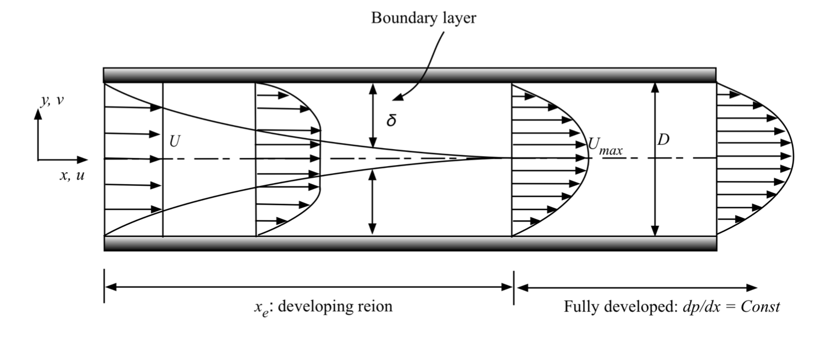

Figure : Fluid Flow Through a Channel

In the fully developed region, the Equation 1 describes the velocity profile.

(1)

Where dp/dx is the pressure gradient, y is the vertical position, h is the channel height (depicted as D in Figure 1), and μ is the dynamic viscosity of the fluid. The average velocity can then be found by integrating over the area the fluid flows through, as shown in Equation 2.

(2)

If Equation 1 is divided by Equation 2, the result will be Equation (3).

(3)

Given the pressure distribution, dp/dx, the ratio of volume flow rate (Q) to channel width (w) can be found, as shown in Equation 4.

(4)

Equations 1, 2, 3, and 4 describe the exact solutions for fluid velocity and volume flow in the fully developed region of the channel. However, there exists a region where there is no exact solution, which is the developing region. In the developing region, two boundary layers grow from the channel leading edge and eventually merge together at the center of the channel far downstream. As shown in Figure 1, the entrance length xe denotes the streamwise distance from the leading edge to the position where the boundary layers meet.

In the developing region, there are only numerically calculated values for velocity and pressure. However, the boundary layer takes the approximate form of Equation 5 as it approaches the center of the channel.

(5)

In this equation, C denotes some constant value which y approaches, x is dependent variable, and τ is the constant that x depends on. Given τ, y is approximately C when x = 4τ.

**Procedure:**

Using the Fluent package given by ANSYS, numerical simulations on the incompressible, 2-D, viscous, laminar channel flow were calculated. To begin with, the geometry of the channel was chosen on Fluent. This included the channel height and length. The mesh for the channel was also chosen (See Appendix 1). The meshes are the regions where answers are numerically generated through finite element analysis.

For the channel, the fluid was also chosen to be liquid water. The boundary conditions were set, and the inlet velocity was also set based on the Reynolds Number and fluid properties using Equation 6.

(6)

The simulation was calculated based off of the channel and the conditions given. The converging history for the solution was given as well (See Appendix 2). The velocity profile for the Reynolds number was then calculated and recorded (See Appendix 3). The velocity at 12 different axial locations was recorded as well.

The data was recorded and then repeated for 8 different Reynolds numbers, each less than 1000 (to ensure laminar flow). With these results, the velocity profiles were graphed at different axial positions (See Appendix 4) against the exact solution for the fully developed region. Using the numerical results from the axial velocity, the pressure gradient and the volume flow rate with respect to the channel width were calculated using Equations 2 and 4. These results were then compared to the volume flow rate given by the exact equation (first part of Equation 4).

Using the eight different inlet velocities/Reynolds numbers, the entrance length was then calculated for each situation. To do this, the velocity profiles were analyzed for each Reynolds number. To begin with, the ratio of the velocity profile to the average velocity is given as 1.5 at the center of the channel height. As shown in Appendix 4, the ratio of velocity of the fluid at the center of the channel to the average velocity approaches 1.5 as the axial displacement increases. This is also shown for various Reynolds numbers in Appendix 5.

The rate at which the ratio of the velocity at the center of the channel to the average velocity approaches 1.5 is very similar to Equation 5. In this situation, C would take on the value 1.5, as this is the maximum value y could attain. Given this relationship, the value of τ was calculated for each Reynolds number. Given the information in Equation 5, the ratio of the velocity at the center of the channel to the average velocity will approximately be 1.5 when x = 4τ. With all of the values now, the entrance length will be approximately be 4τ, as the velocity profile begins modeling that of the fully developed region’s velocity profile at that point.

With the entrance length calculated for each Reynolds number, the ratio of the entrance length and channel height to the Reynolds number was calculated and analyzed.

**Summary of Results:**

For liquid water, the density is 998.2 kg/m3 and the dynamic viscosity is 0.001003 kg/(m-s). The channel height was chosen to be 1 meter, and the channel length was chosen to be 14 meters. To start off, a Reynolds number of 50 was analyzed first. Using equation 6, the inlet velocity was calculated to be 5.02 x 10-5 m/s. The numerical analysis for the fluid flow in the pipe was calculated, and is shown in Appendix 4. The axial velocity was analyzed at the inlet, x = .1m, x = .2m, x = .3m, x = .4m, x = .6m, x = .8m, x = 1m, x = 1.2m, x = 2m, x = 3m, and the outlet. The results are shown in Figure 19. This Figure also shows the velocity profiles with respect to the exact solution of the fully developed region as well.

Using the numerical results given by the simulation, dp/dx and Q were calculated in the fully developed region for a Reynolds number of 50. The pressure distribution was found to drop approximately 6x10-7 Pa/m for this situation. The volume flow rate per unit width was also analyzed, and it came out to be approximately 5.0026x10-5 m^2/s. Using the exact solution, the volume flow rate per unit width was found to be 4.985x10-5 m2/s. Given these two values, the numerically calculated value was found to have a .352 % error with respect to the exact solution.

Using the method described in the procedure, the ratio of the entrance length and channel height to the Reynolds number was then calculated for each Reynolds number, as shown in Table 1.

Table : Entrance Length Calculations

|  |  |  |
| --- | --- | --- |
| **Average Velocity (m/s)** | **Reynolds Number** | **(xe/D)/Re** |
| 5.02E-05 | 50 | 0.063 |
| 1.01E-04 | 100 | 0.0574 |
| 2.01E-04 | 200 | 0.062 |
| 3.42E-04 | 340 | 0.0595 |
| 4.82E-04 | 480 | 0.053 |
| 6.23E-04 | 620 | 0.0513 |
| 7.64E-04 | 760 | 0.0505 |
| 8.04E-04 | 800 | 0.0501 |

As shown in the table, the ratios fell between .05 and .065. The average ratio was found to be approximately 0.0559, which leads to Equation 7.

(7)

The numerical equation typically used to find the entrance length for laminar flow is given by Equation 8.

(8)

The percent error between the two values is approximately 6.83 percent. With this in mind, an approximate solution that relates the entrance length, the channel height, and the Reynolds number can be formed to analyze the fully developed and developing regions using Equation 7.

**Appendix 1: Mesh Generation**

The following figure depicts a close up view of the mesh generation for the channel flow. The channel height is 1 meter and the channel length is 14 meters. The element size is .05 and the growth rate is 1.5.

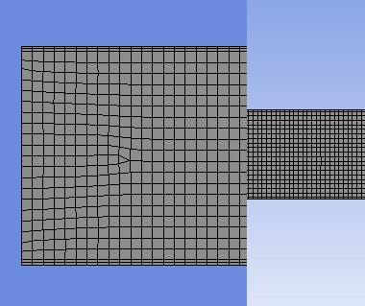

Figure : Mesh Generation

**Appendix 2: Convergence Histories for Different Reynolds Numbers**

The following figures depict the numerical solution converging histories for each CFD simulation.

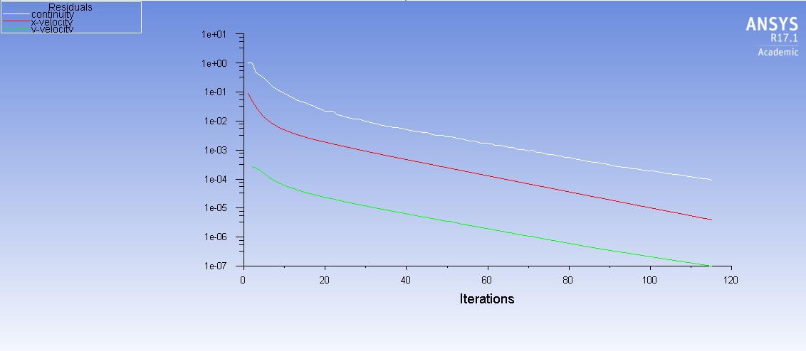

Figure : Reynolds Number of 50

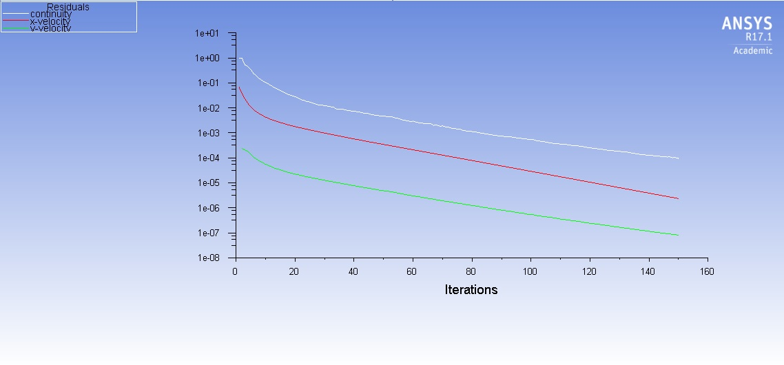

Figure : Reynolds Number of 100

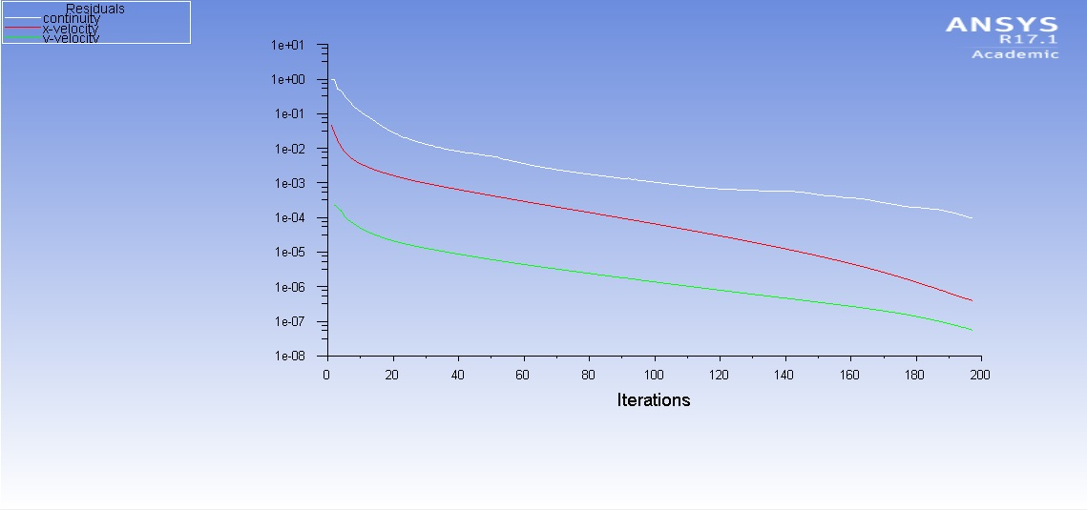

Figure : Reynolds Number of 200

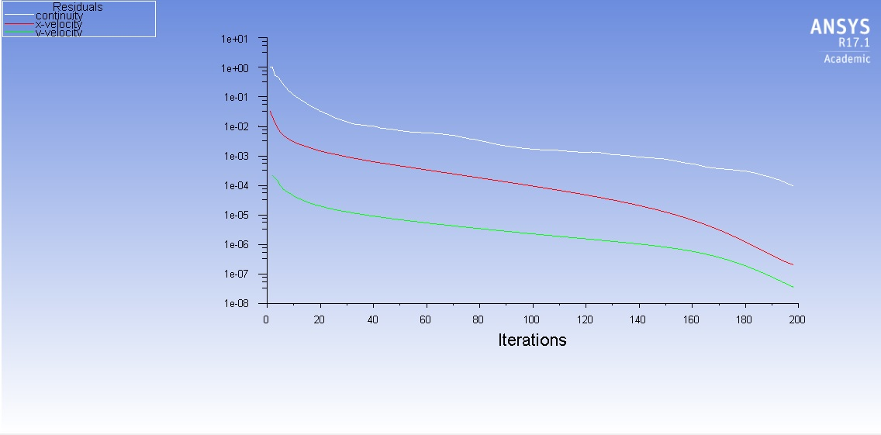

Figure : Reynolds Number of 340

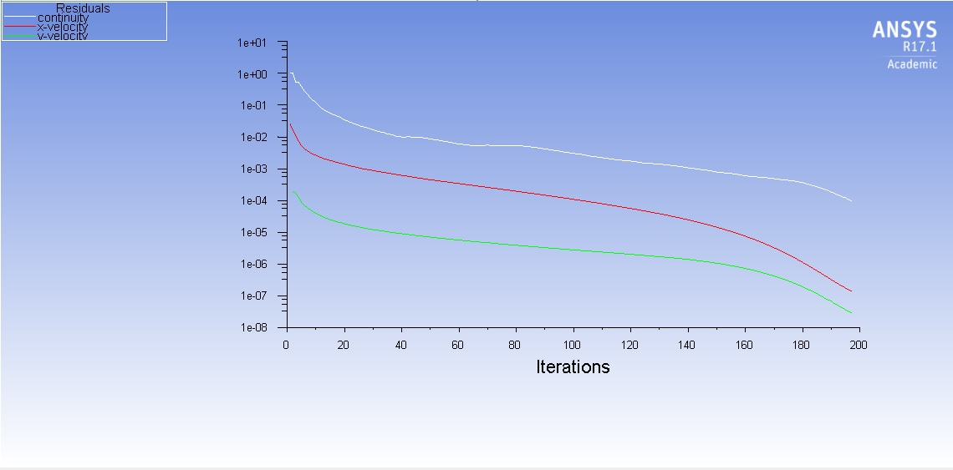

Figure : Reynolds Number of 480

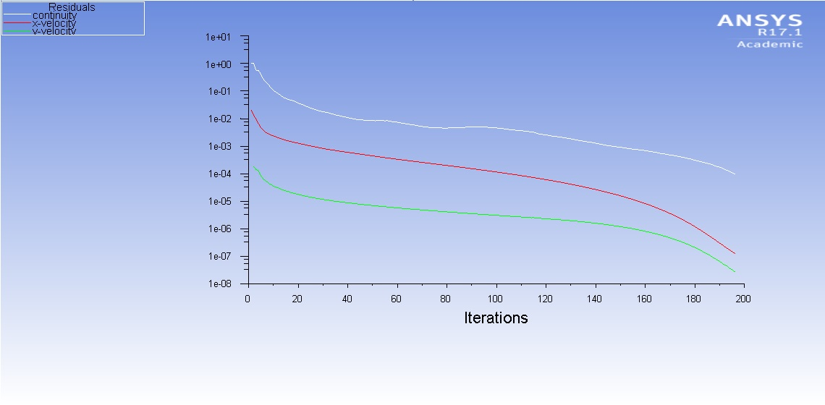

Figure : Reynolds Number of 620

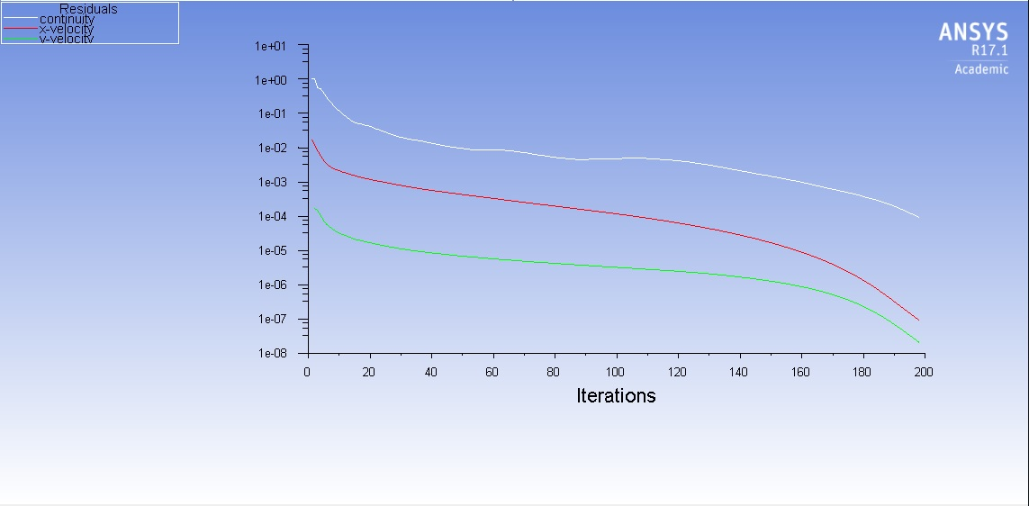

Figure : Reynolds Number of 760

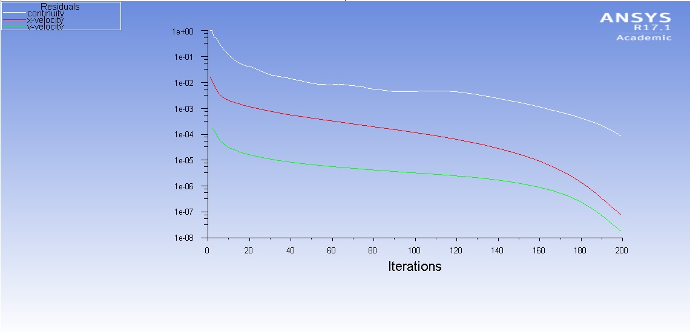

Figure : Reynolds Number of 800

**Appendix 3: Velocity Profile Analysis for Different Reynolds Numbers**

The following figures depict the numerical simulations for the velocity profile analysis of the fluid. The length of the channel is 14 meters, and the channel height is 1 meter.

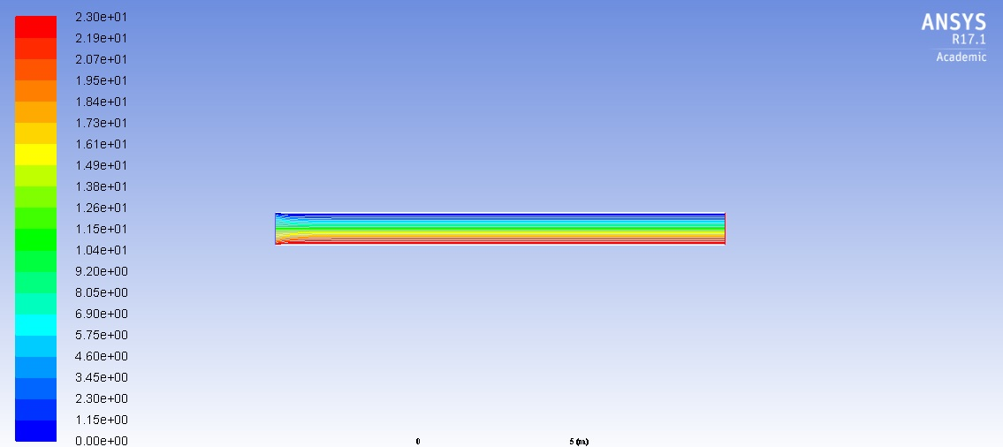

Figure : Reynolds Number of 50

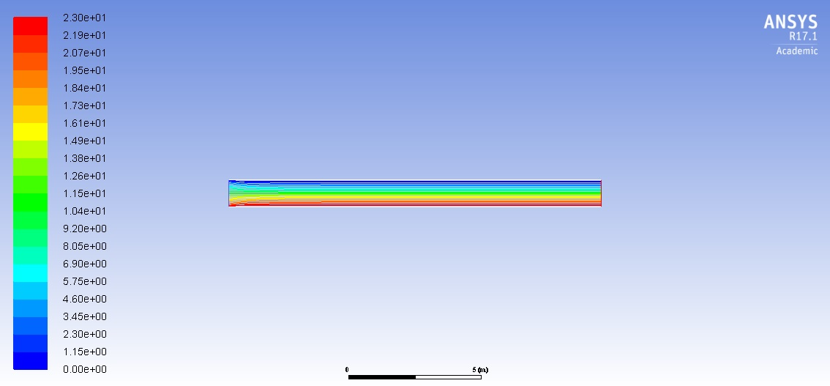

Figure : Reynolds Number of 100

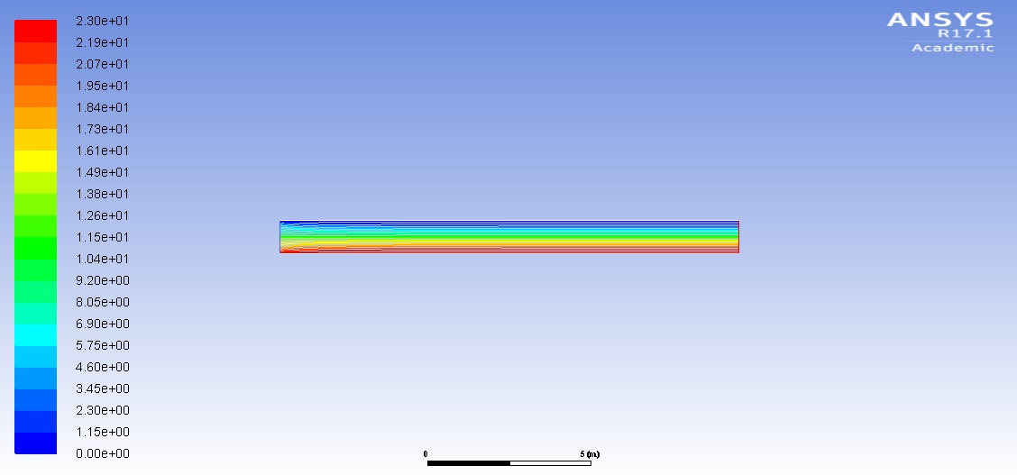

Figure : Reynolds Number of 200

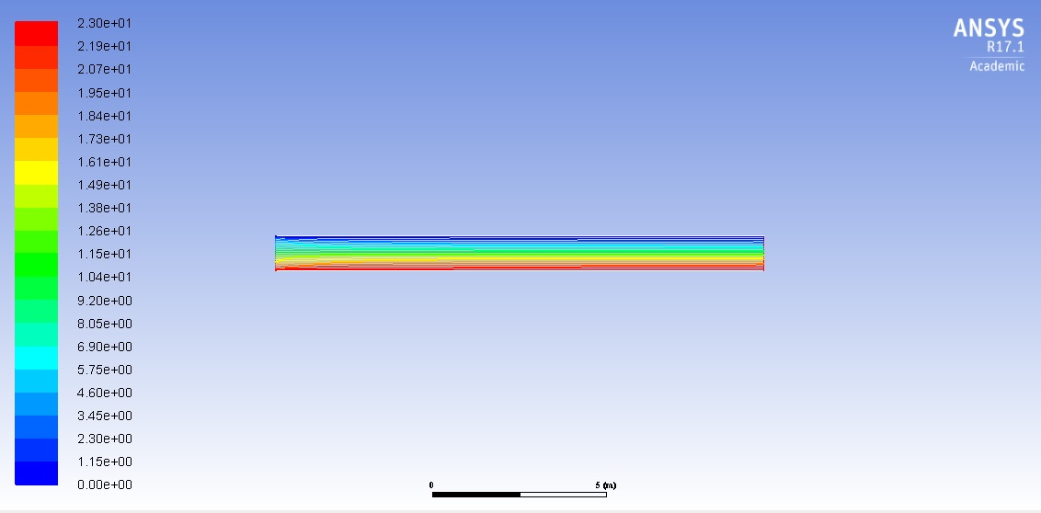

Figure : Reynolds Number of 340

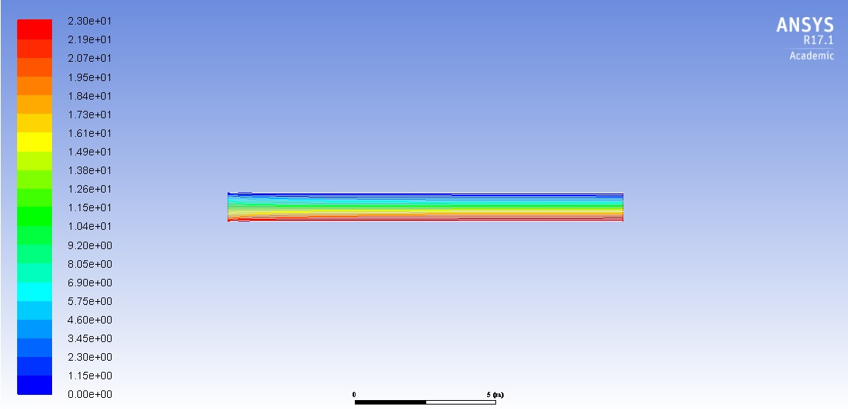

Figure : Reynolds Number of 480

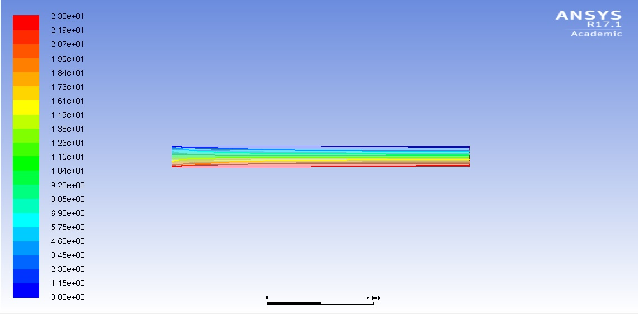

Figure : Reynolds Number of 620

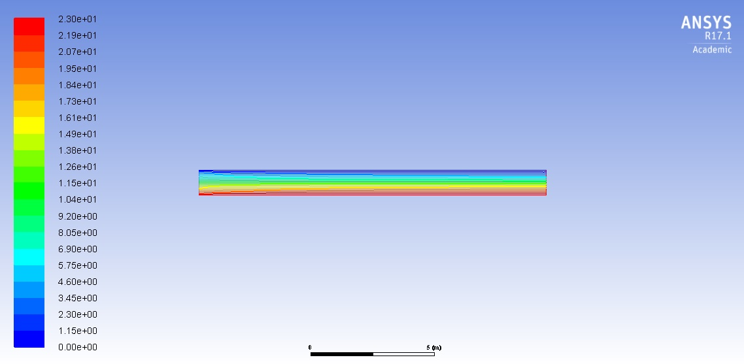

Figure : Reynolds Number of 760

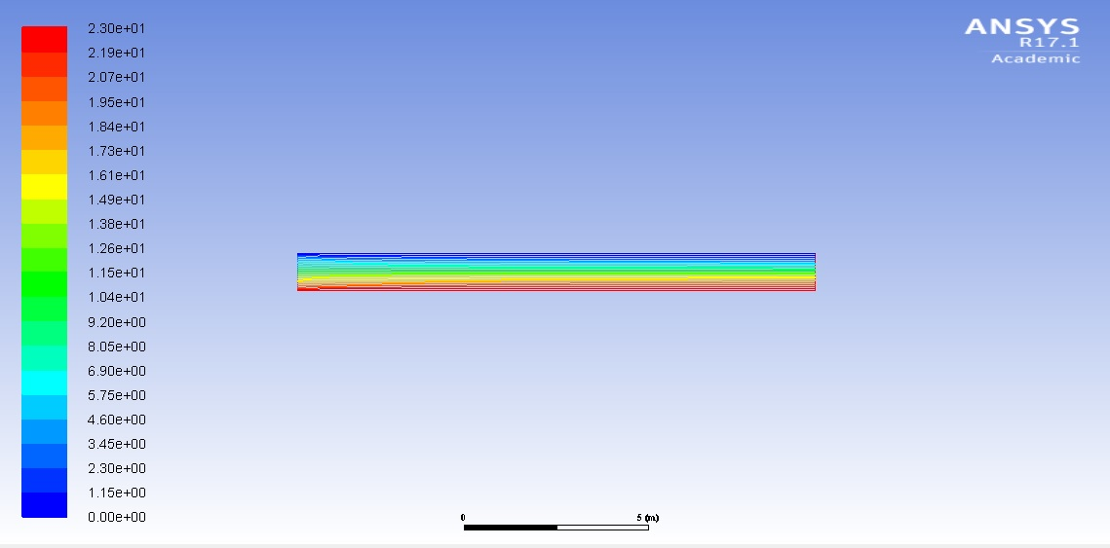

Figure : Reynolds Number of 800

**Appendix 4: Velocity Profiles by Axial Displacement**

The following figure depicts the velocity profile of the fluid at various axial displacements beginning at the inlet (x = 0 meters) and ending at the outlet (x = 14 meters) for a Reynolds number of 50. The exact solution is also plotted for comparison. The x-axis is the ratio of the axial position to the channel height. The y-axis is the ratio of the axial velocity to the average velocity.

Figure : Velocity Profiles for Reynolds Number of 50

**Appendix 5: Developing Region Calculation**

The developing region is where two boundary layers grow from the channel leading edge and eventually merge together at the center of the channel far downstream. In this region, there does no exist an exact solution. The entrance length denotes the streamwise distance from the leading edge to position where the boundary layers meet.

The following graphs show the solution methods used to obtain the entrance length. The x-axis represents the axial displacement. The y-axis depicts the ratio of the velocity of the fluid flow at the center of the channel (y = 0) to the average velocity of the fluid.

Figure : Reynolds Number of 50

Figure : Reynolds Number of 100

Figure : Reynolds Number of 200

Figure : Reynolds Number of 340

Figure : Reynolds Number of 480

Figure : Reynolds Number of 620

Figure : Reynolds Number of 760

Figure : Reynolds Number of 800